Hot Water Recirculation System
By Chris Hayes

October 2020
Email: chris@shawcomms.com.au
Website – www.shawcomms.com.au

Software
Raspberry Pi
Setup a Raspberry Pi with the latest version of Home Assistant Core– link below has a very good step by step instruction set. My Pi is a dedicated Pi for Home Automation.
Home Assistant
Link - https://www.home-assistant.io/getting-started/
This is only one method, there are a few others such as a docker version, Virtual drive (VM ware), PC Based etc to use Home Assistant.
I chose the Raspberry Pi version. I use the Raspberry Pi to perform my Home Automation System including the Hot Water Recirculation System.
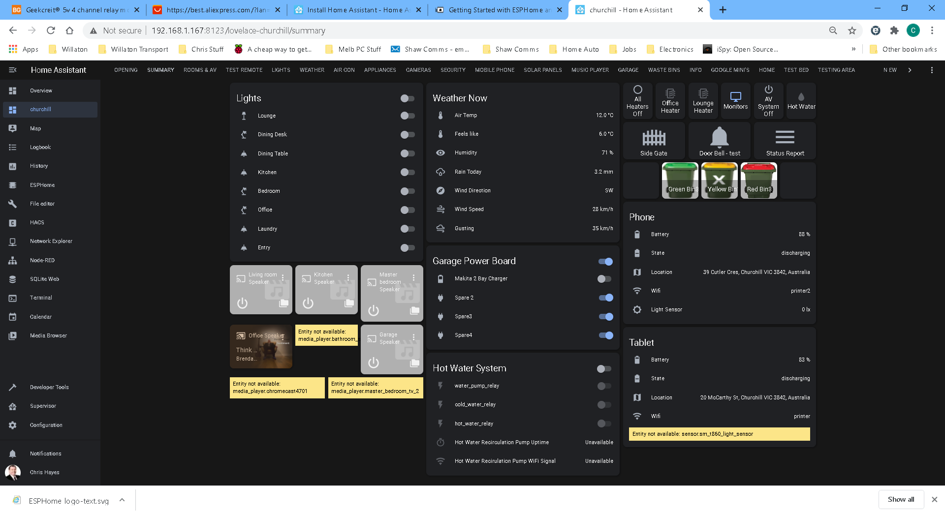
Screen shot of some of the features of my Home Assistant.
ESPHome
Once the Home Assistant is loaded - install ESP Home
Link: https://esphome.io/guides/getting_started_hassio.html
This guide helps you install the ESPHome core for Home Assistant.
Screen shot of at the time the various control devices I use in ESPHome and therefore in Home Assistant.
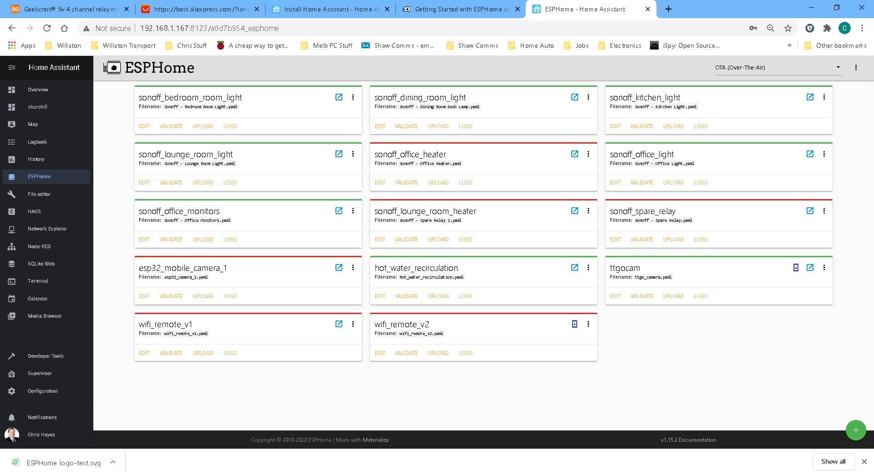

ESPHome setup for a ESP8266
1 – Click the + button (bottom right) this initiates the wizard to add an new device
+ button

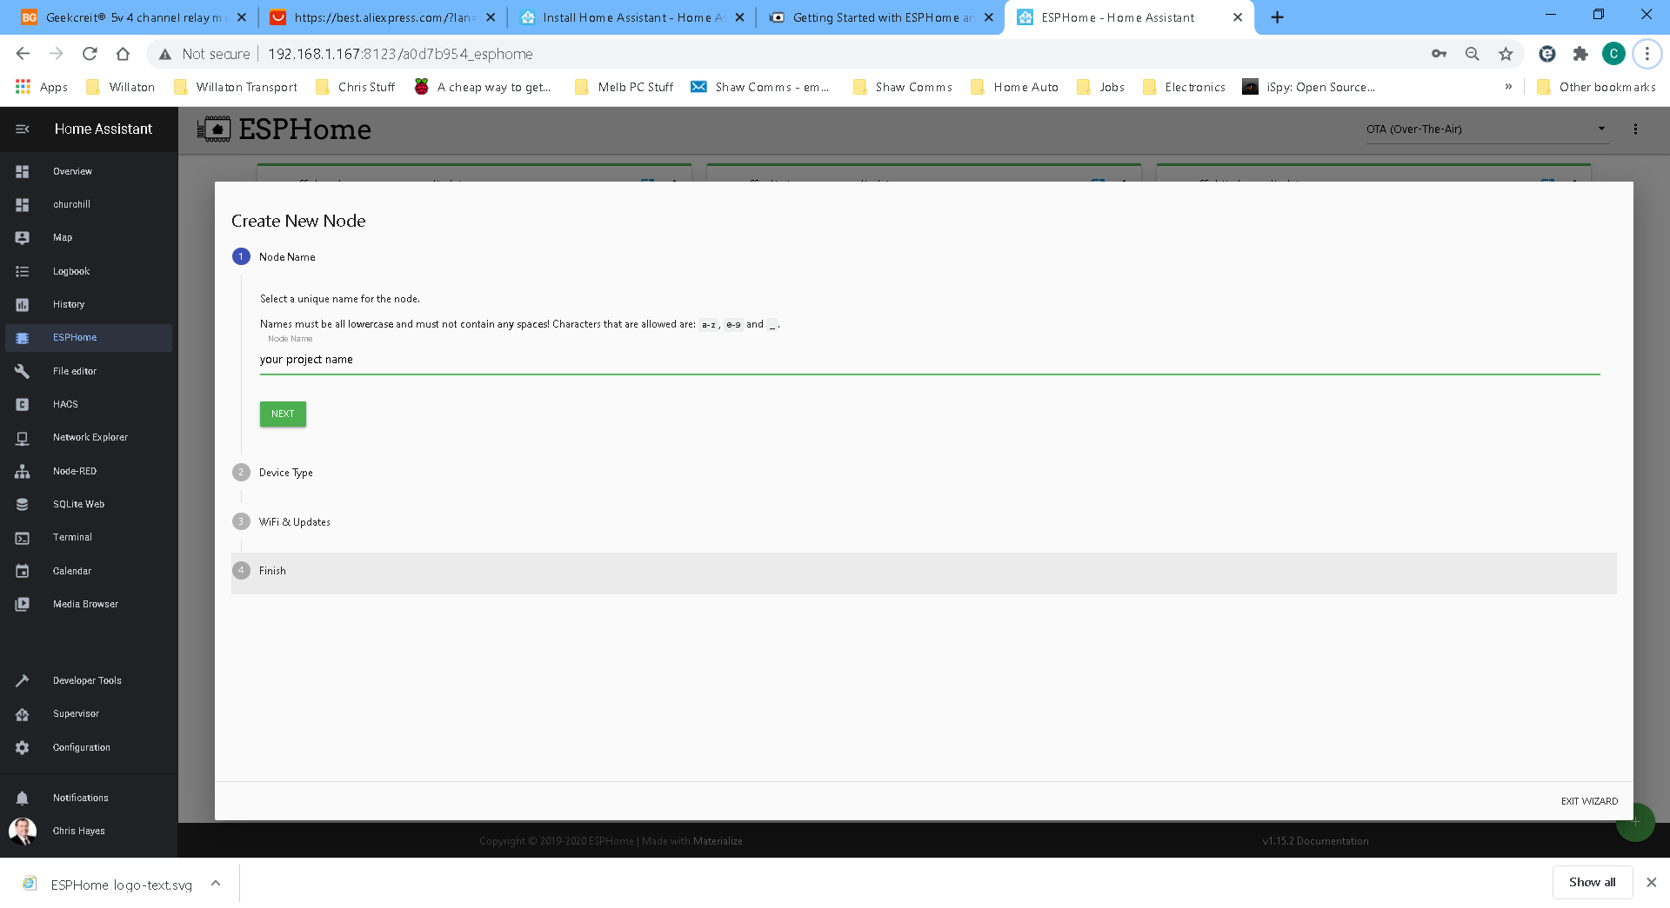
Type name for the project – ie your_project_name (ensure there are underscores - no spaces)
Click NEXT
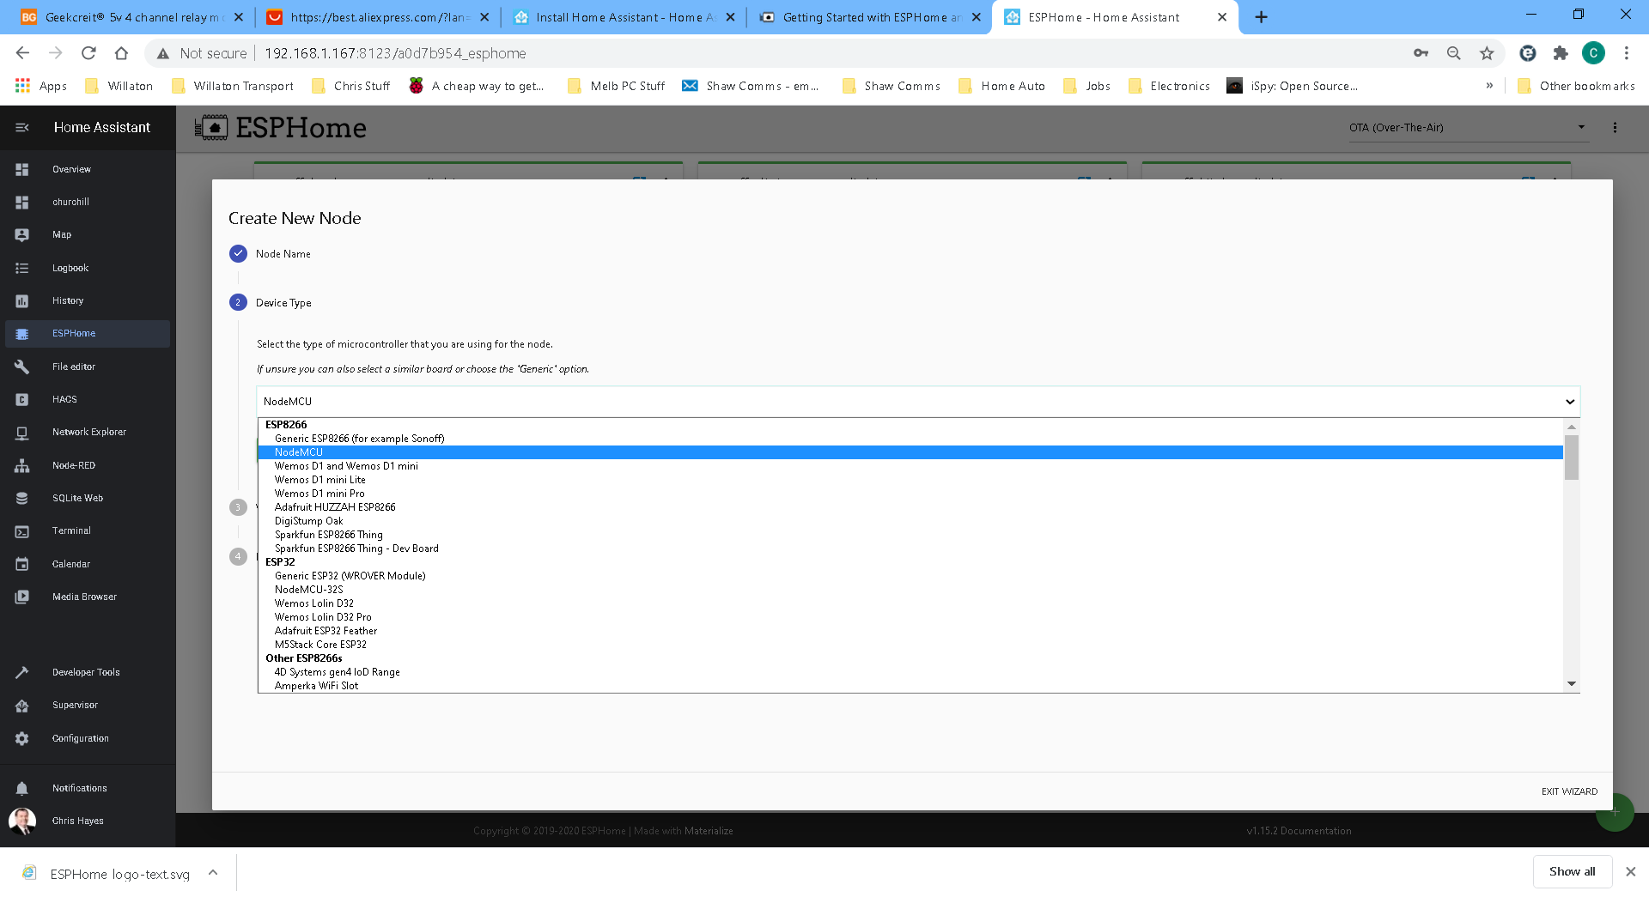
Select your version of ESP8266 or ESP32 device (note this is critical to get it right)
I selected the ESP8266 NodeMCU for my project
Click NEXT
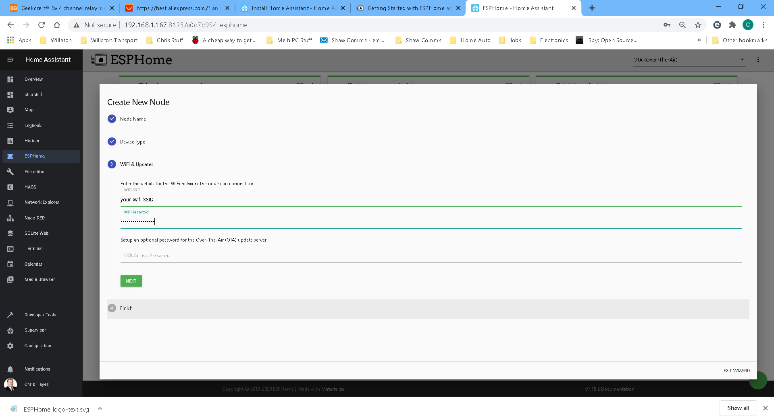
Enter your wifi credentials – SSID and password
Click NEXT
Then click SUBMIT
The first time you create a project you need to load the ESPHome sketch onto the ESP device.
I suggest adding a couple of lines before uploading.
web_server:
port: 80
This is a very useful monitoring tool whilst program is running. I will demo this later.
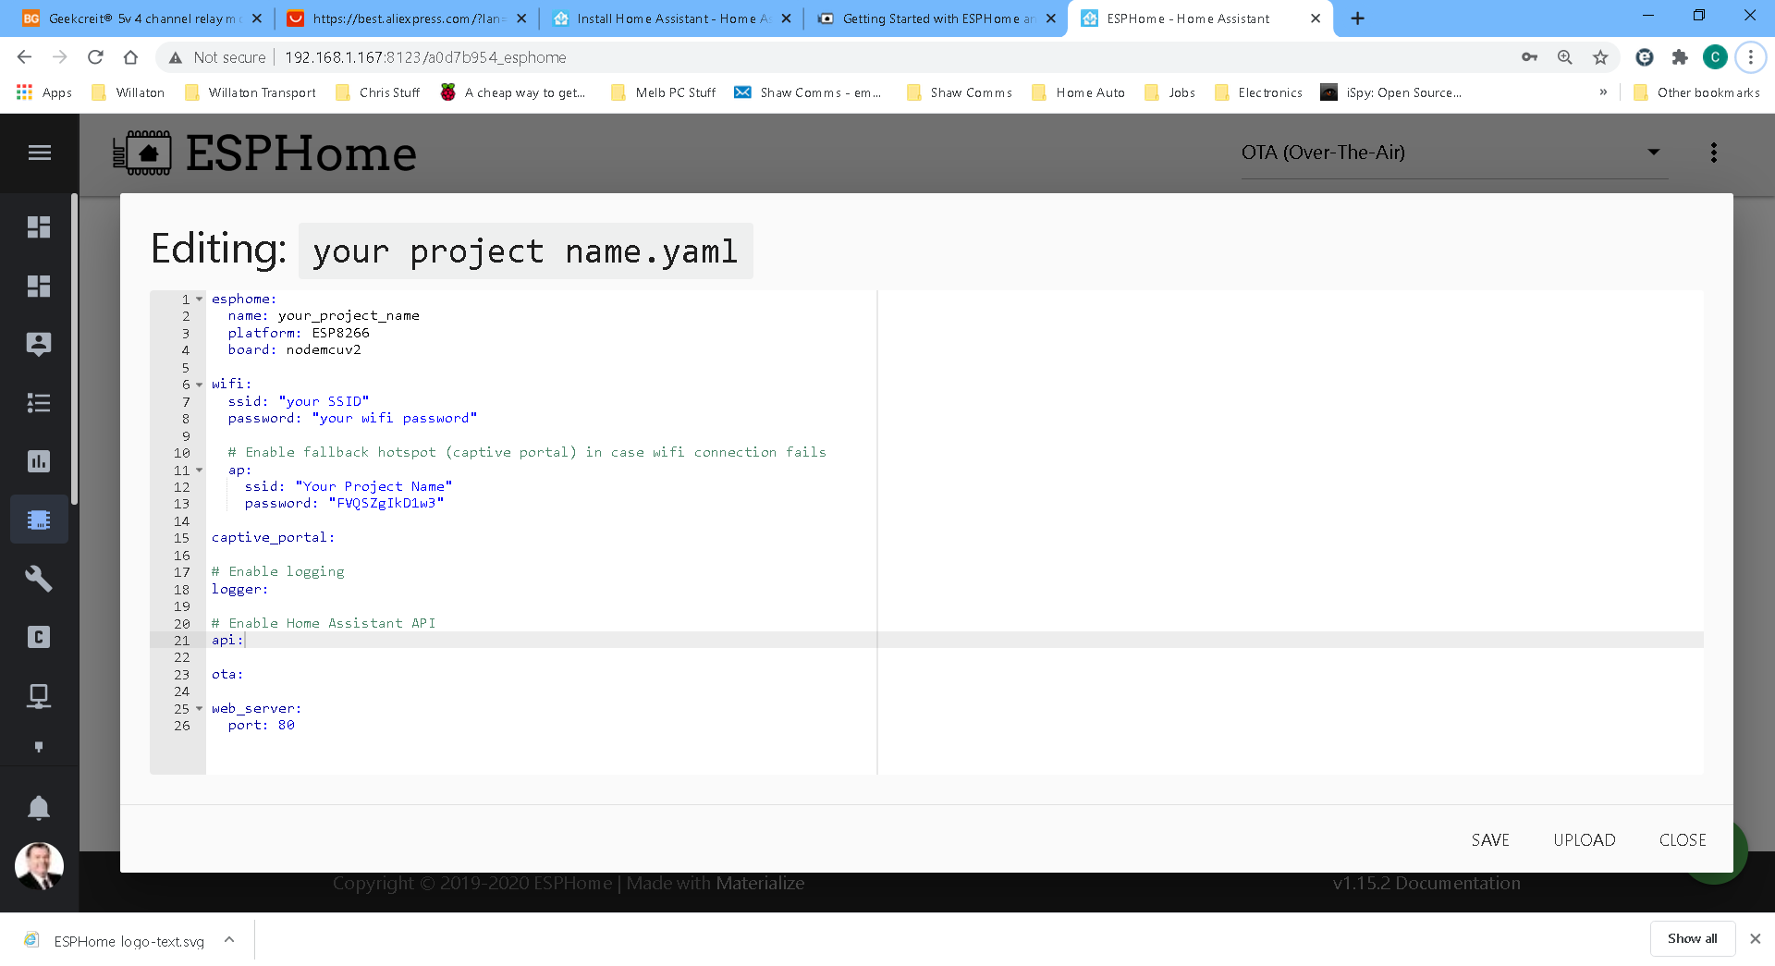
Raw code for basic upload (no smarts)

esphome:
name: your_project_name
platform: ESP8266
board: nodemcuv2
wifi:
ssid: "my_ssid"
password: "my_wifi_password"
manual_ip:
static_ip: 192.168.1.52
gateway: 192.168.1.1
subnet: 255.255.255.0
# Enable fallback hotspot (captive portal) in case wifi connection fails
ap:
ssid: "Your Project Name"
password: "FVQSZgIkD1w3"
captive_portal:
# Enable logging
logger:
# Enable Home Assistant API
api:
ota:
web_server:
port: 80

Make the adjustments as I have made by adding the manual IP address as required within your Network.
Save the yaml code
Close the yaml editor
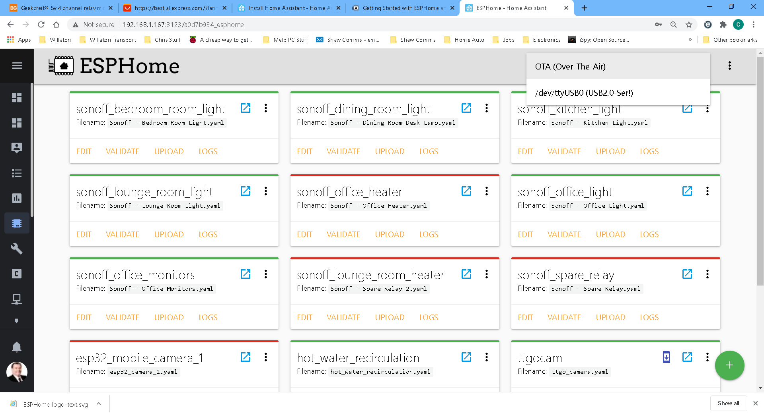
At the top right there is a OTA (Over-The-Air). If you have inserted a USB lead between the Raspberry Pi and the ESP device the drop down will show the USB device.
Select the USB Serial port as this is the communications port to use for the first upload.
In the yaml code there is a line with ota: this means that the device will accept uploads via the Over The Air facility. So once this code is sent to the device via the USB port then the further uploads can be done via OTA.

You may need to use a USB to TTL device if there is no USB connector on the ESP device.
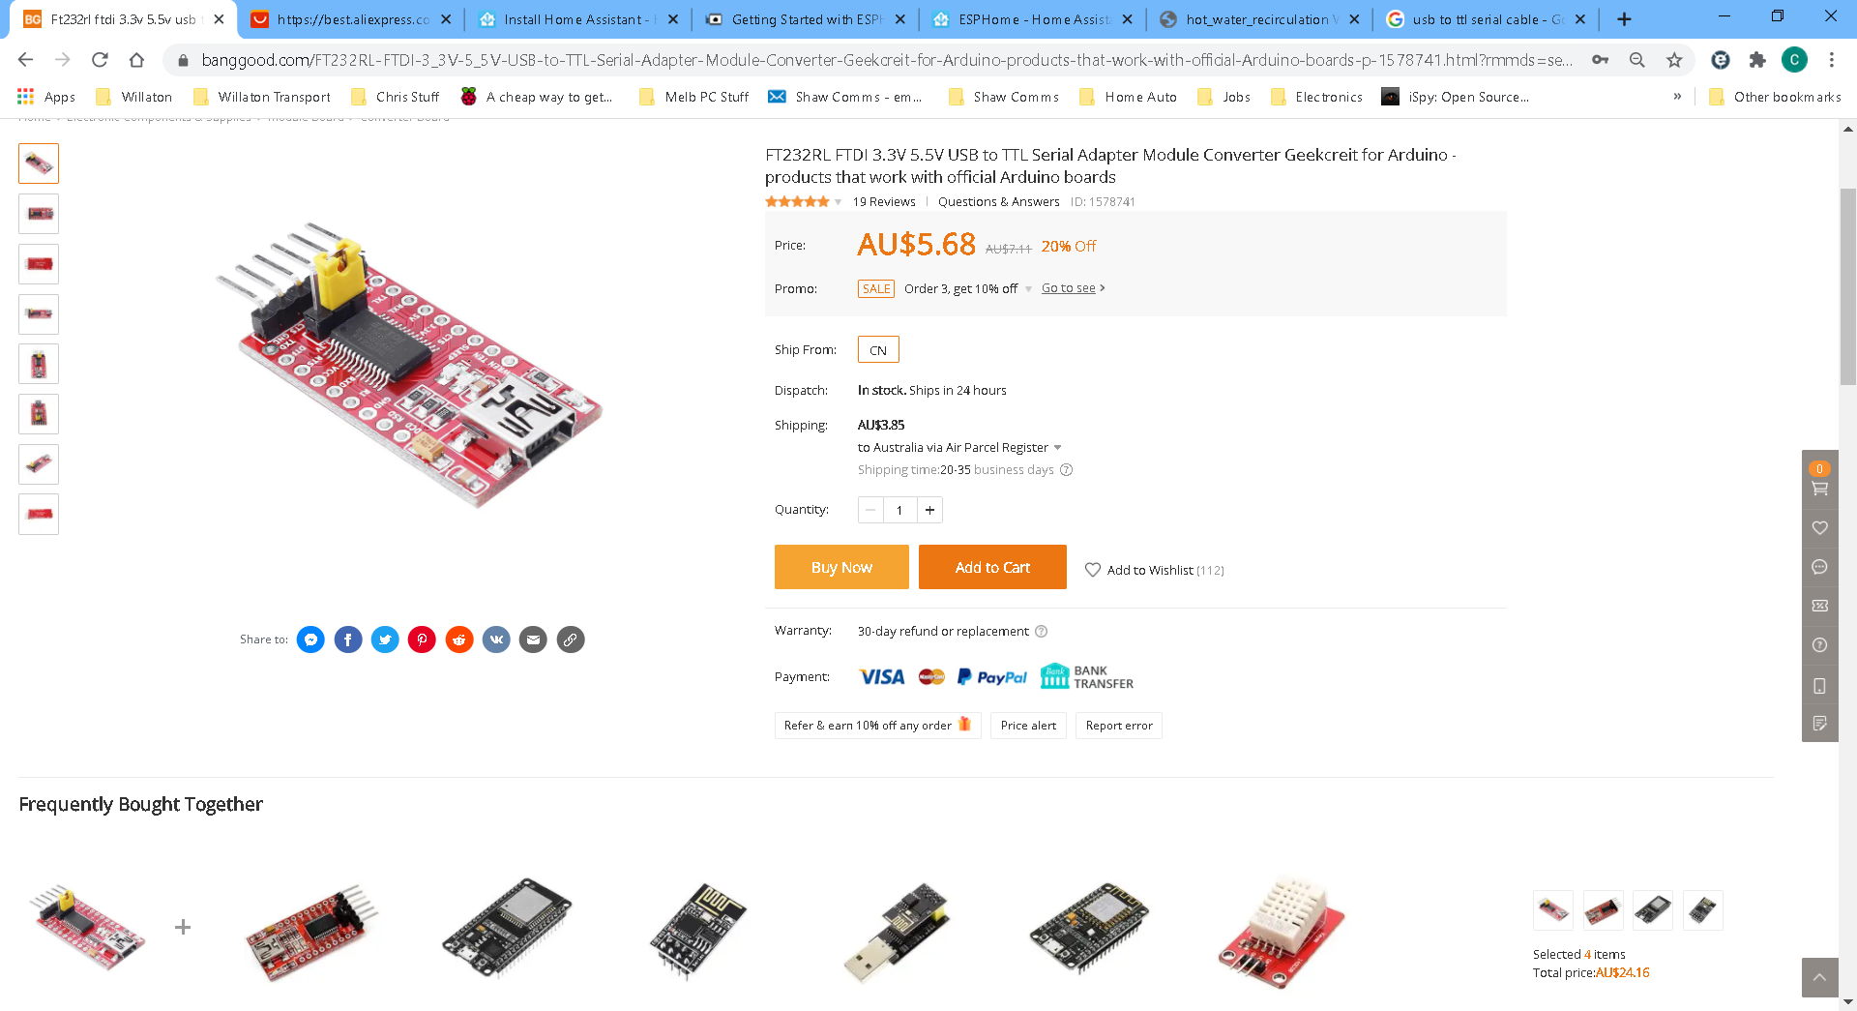
Link: https://www.banggood.com/FT232RL-FTDI-3_3V-5_5V-USB-to-TTL-Serial-Adapter-Module-Converter-Geekcreit-for-Arduino-products-that-work-with-official-Arduino-boards-p-1578741.html?rmmds=search&cur_warehouse=CN

Click Validate – this is checking some settings and the some of the program yaml file and provide you with a response as to the file being ready to upload.
Click Upload
This will complie the code – this will download from various online and offline libraries the various required features or functions you require in your yaml file.
Be patient as there is a lot of downloading and compling so may take sometime. Occassionally the system may hang but gernerally it will finish the upload.
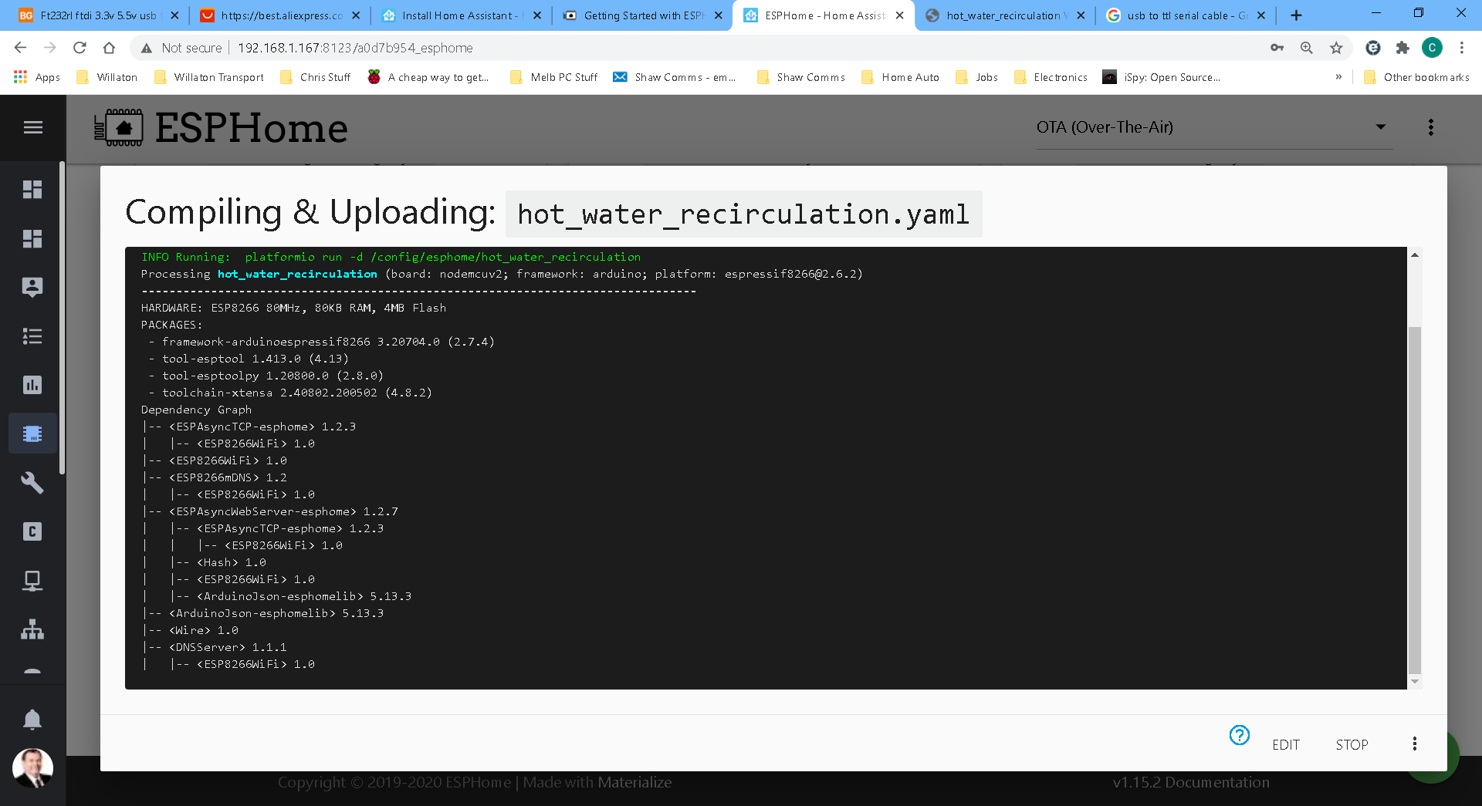
Once it compiles, the code is then uploaded to the device automatically.
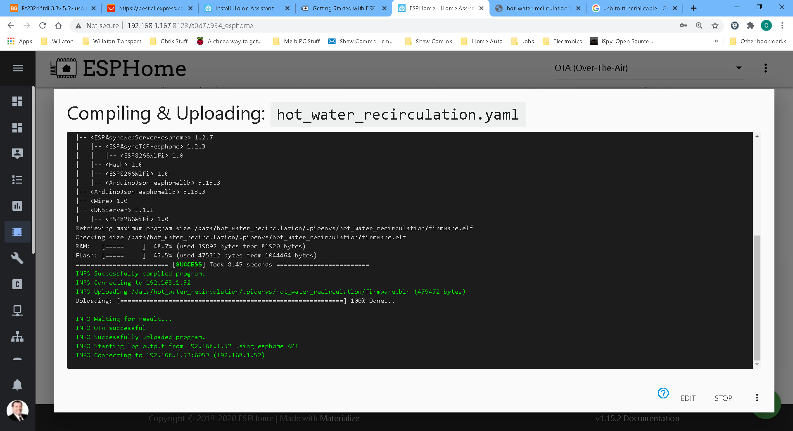

Click logs shows the working status of some variables and assests on the ESP device.
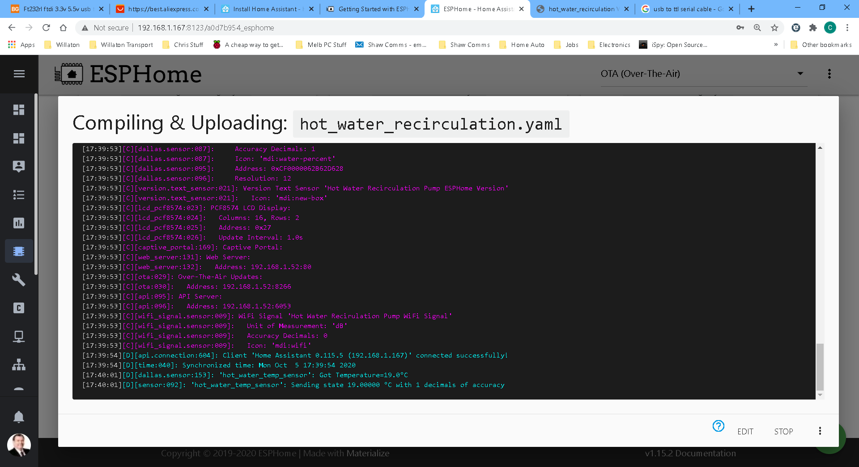
Once the device has restarted after the upload you can now select the OTA (top right) If all has gone correctly the device will have a green line showing connected.
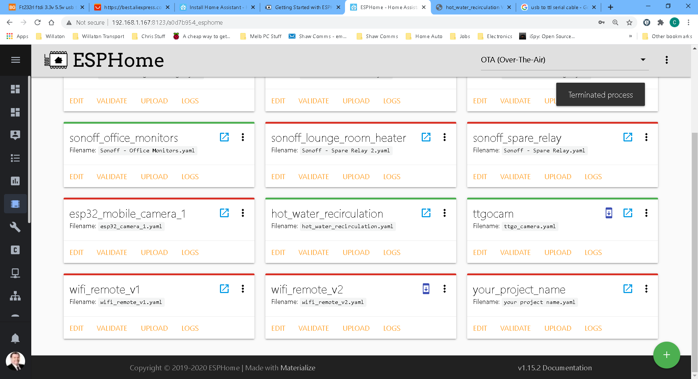
From now on upload via Ota and the USB lead is no longer required.

If you have trouble uploading for the first time via the USB port on the Home Assistant Raspberry Pi, you can try the following.
Try uploading the Binary Code to the ESP Device via other ESP file flashers
To get the Binary File from the complied code click the the three dots on your device
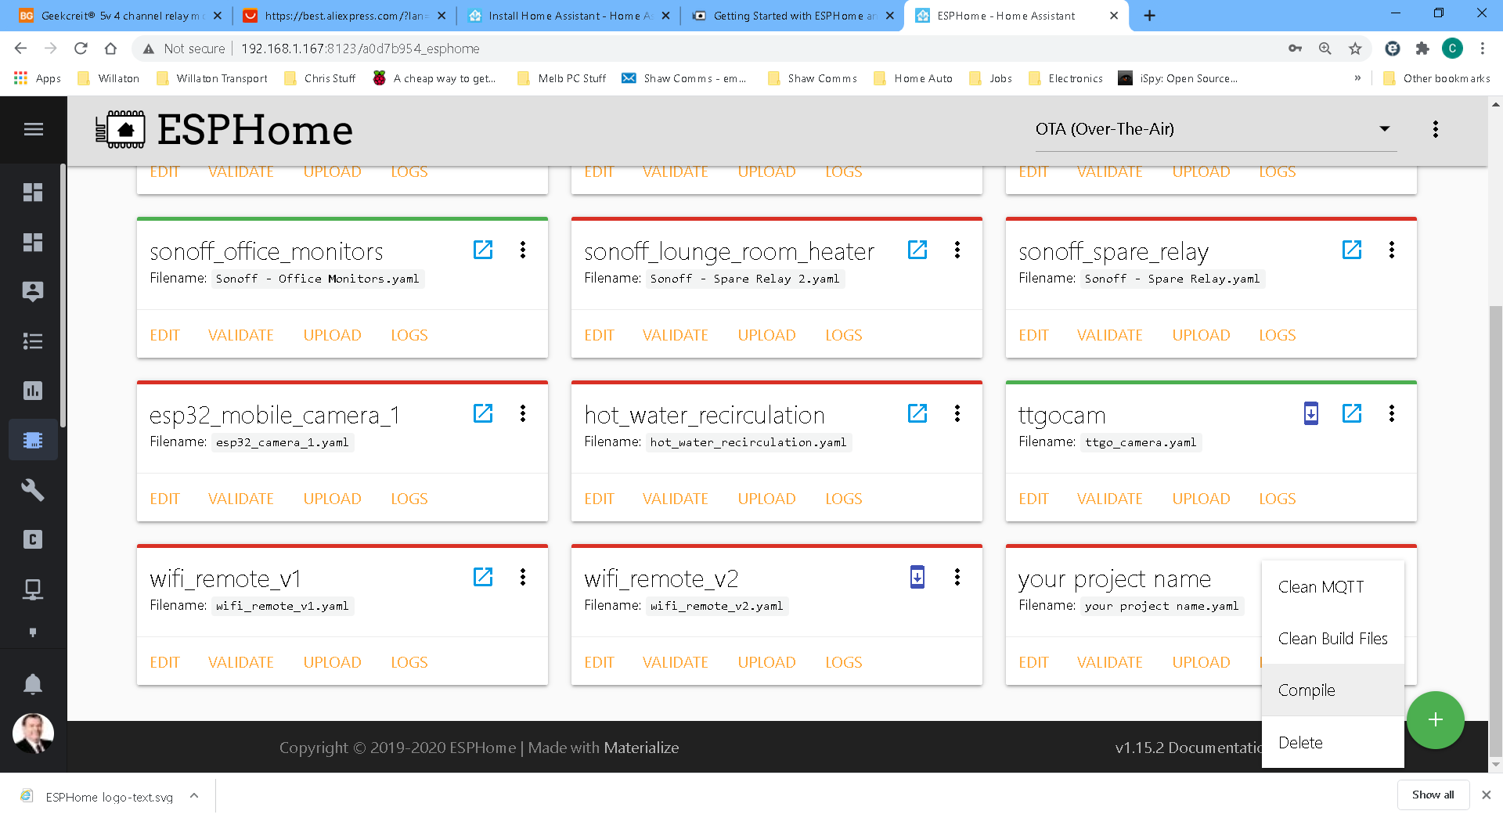
Click Compile
Once Compiled – click DOWNLOAD BINARY
Save it somewhere you can find it.
Open your favourite ESP Flasher program – I use two – Tamotorizer
Method 1: Not always successful. Is great for Sonoffs
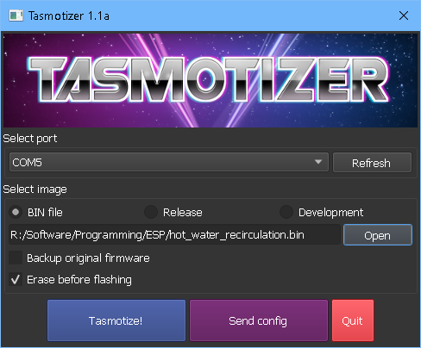
Use correct USB PORT
Open the BINARY FILE
Ensure the Erase before flashing is ticked
Click Tasmotize! And the Binary code will then be uploaded
Method 2
ESPHome-Flasher – this very robust.
Link: https://github.com/esphome/esphome-flasher/releases

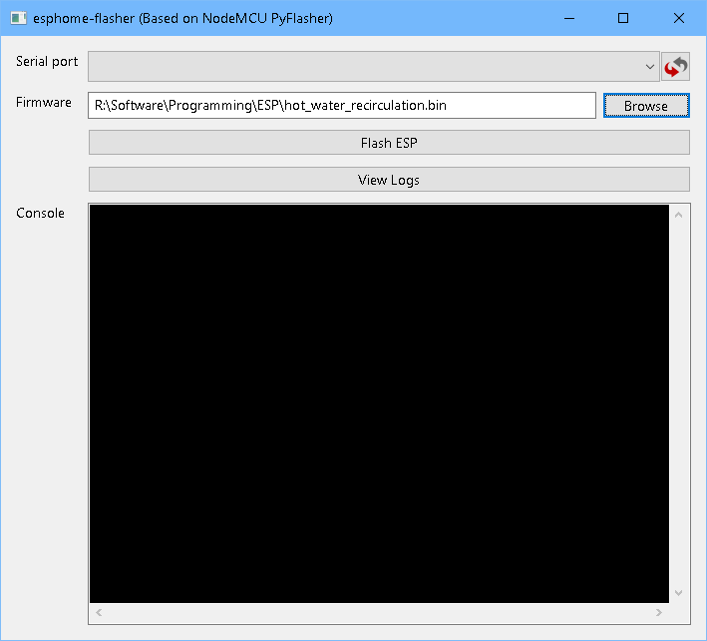
Select USB port
Find the Binary File to upload
Click Flash ESP
If all good then the Binary Code uploads.
This program just works and automatically Erases before upload.

Found a new one that might be useful.
https://github.com/tasmota/tasmota-pyflasher

My Code explained:
So down to the code for my structure/system. In green are comments to help readers understand the code.
Other than the I2C lines D1,D2 the other pins on the ESP8266 are NOT crictial in allocation as the signals get setup as GPIO’s (high/low – relays, Motion sensor), Data signal – temp sensor.

esphome:
name: hot_water_recirculation
platform: ESP8266 # board type
board: nodemcuv2
platformio_options: # setup parameters for upload
upload_speed: 115200
board_build.f_flash: 80000000L
wifi:
ssid: "my_ssid"
password: "my_wifi_password"
manual_ip:
static_ip: xxx.xxx.xxx.xxx
gateway: xxx.xxx.xxx.xxx
subnet: 255.255.255.0

# Enable fallback hotspot (captive portal) in case wifi connection fails
ap:
ssid: "Hot Water Recirculation"
password: "KpIuppPrBpG2"

captive_portal:

# Enable logging
logger:

# Enable Home Assistant API
api:

web_server: # for viewing in a web browser
port: 80

ota:

time:
- platform: homeassistant # use home assistant time stamp for the display text
id: homeassistant_time

i2c: # 1602 LCD PCF8574 LCD display I2C connection pins on ESP8266
sda: D2
scl: D1
scan: True

display:
- platform: lcd_pcf8574 # type of display being used
dimensions: 16x2
address: 0x27 # I2C address of this display
lambda:
if (id(relay1).state == true) # if pump ON display PUMP ON message
{
it.print(4,0,"Pump-On ");
it.strftime(1,1, "%d-%m-%y %H:%M", id(homeassistant_time).now());
}
else
{
it.print(4,0,"Pump-Off"); # if pump OFF - display PUMP OFF message
it.strftime(1,1, "%d-%m-%y %H:%M", id(homeassistant_time).now());
}
dallas: # temp sensor settings
- pin: D4
#number: D4
update_interval: 10sec
#name: hot_water_temp_sensor

switch:
- platform: template # setup actions of Relay 1 ON OFF
name: "water_pump_relay"
optimistic: true
id: pump_relay
turn_on_action:
- switch.turn_on: relay1
turn_off_action:
- switch.turn_off: relay1

- platform: template # setup actions of Relay 2 ON OFF
name: "hot_water_relay"
optimistic: true # this is here because I was always optimistic this will work and it did work
id: hot_water_relay
turn_on_action:
- switch.turn_on: relay2
turn_off_action:
- switch.turn_off: relay2

- platform: template # setup actions of Relay 3 ON OFF
name: "cold_water_relay"
optimistic: true
id: cold_water_relay
turn_on_action:
- switch.turn_on: relay3
turn_off_action:
- switch.turn_off: relay3

- platform: gpio # setup ESP8266 Pin for Relay 1
id: relay1
pin: D5 # GPIO14
inverted: yes

- platform: gpio # setup ESP8266 Pin for Relay 2
id: relay2
pin: D6
inverted: yes

- platform: gpio # setup ESP8266 Pin for Relay 3
id: relay3
pin: D7
inverted: yes

- platform: gpio # setup ESP8266 Pin for Relay 4 future use
id: relay4
pin: D8
inverted: yes

sensor:
- platform: wifi_signal # create a sensor for viewing the wifi signal strength
name: "Hot Water Recirulation Pump WiFi Signal"
update_interval: 60s
- platform: uptime
name: "Hot Water Recirculation Pump Uptime"

# adding logic and smarts for the Dalss Temp sensor. Test if over 35deg turn off pump as temp reached
#setup strucutre of the sensor ie unit of measure, name, what icon to use,
- platform: dallas
address: 0xCF0000062B62D628
name: "hot_water_temp_sensor"
id: hot_water_temp_sensor
unit_of_measurement: "°C"
icon: "mdi:water-percent"
on_value_range:
above: 27.0
then:
- switch.turn_off: relay1 # switch off relay 1 then a delay of 0.5 sec before next relay trun off etc once temp reached
- delay: 500ms
- switch.turn_off: relay2
- delay: 500ms
- switch.turn_off: relay3

binary_sensor:
# setup ESP8266 and structure for PIR sensor
- platform: gpio
pin:
number: D3
#inverted: yes
name: "pir_sensor"
id: pip_sensor
device_class: motion
on_press:
then:
- if: # test if temp below 25 degrees then the motion sensor is enabled again to trigger
condition:
lambda: 'return id(hot_water_temp_sensor).state <25;'
then:
- switch.turn_on: relay1 # switch off relay 1 then a delay of 0.5 sec before next relay trun off etc#
- delay: 500ms
- switch.turn_on: relay2
- delay: 500ms
- switch.turn_on: relay3
# on web browser can see the version of the ESP8266 firmware
text_sensor:
- platform: version
name: "Hot Water Recirculation Pump ESPHome Version"

Web Page Viewer
When adding this code
web_server:
port: 80
You can open a browser and type the IP address of the ESP8266 EPS32 and a web page comes up.
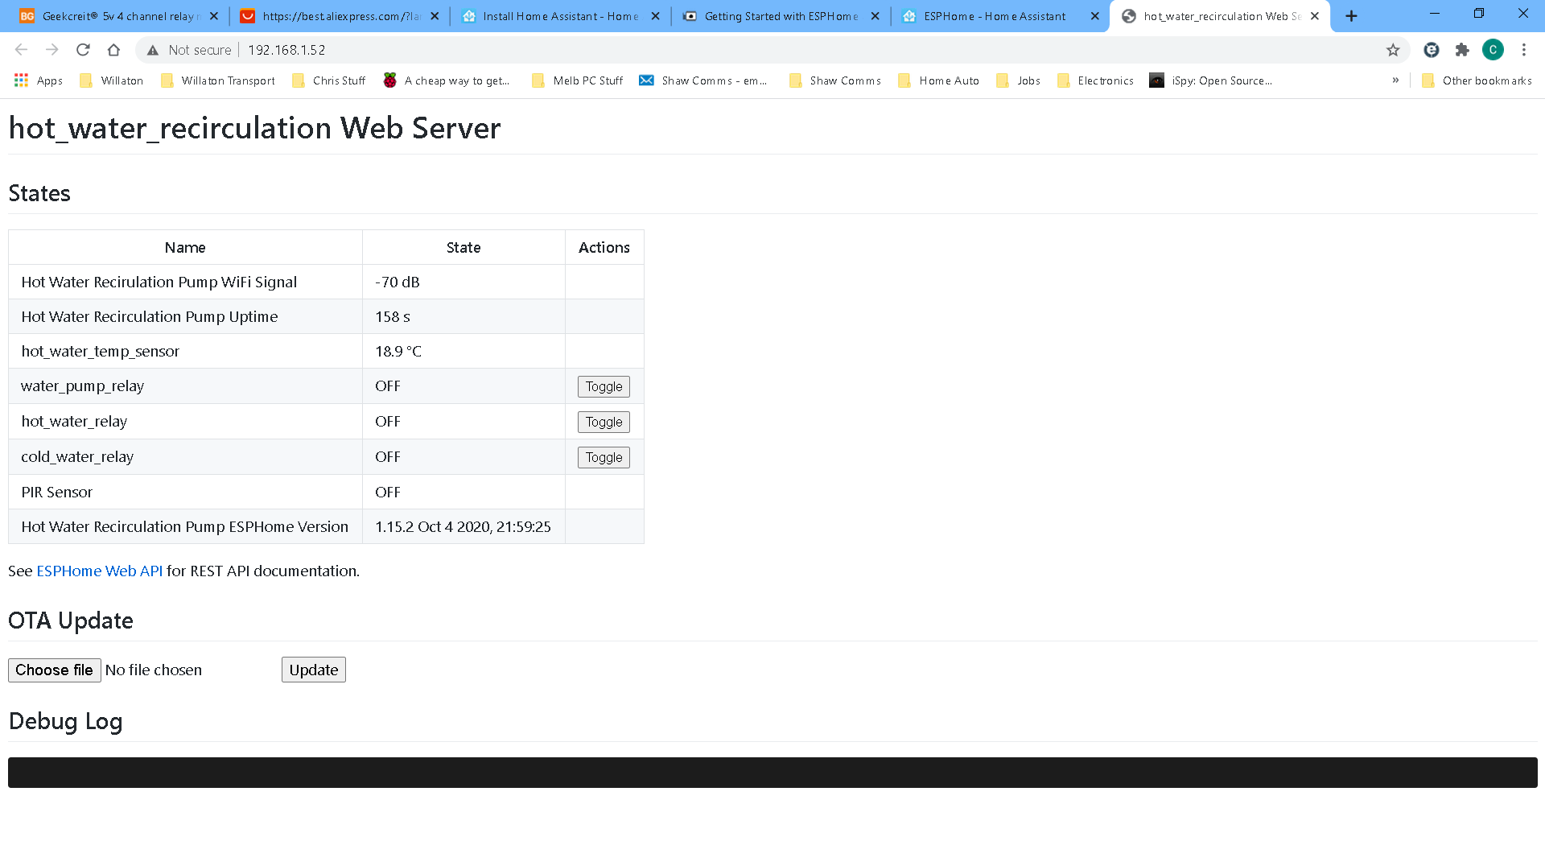
Various data points of your code.
Also turn on or off the relays directly
Also below is the same log page for checking the sequential actions and tasks taken (scroll down).
You also upload new binary files if needed to for other setups or structures

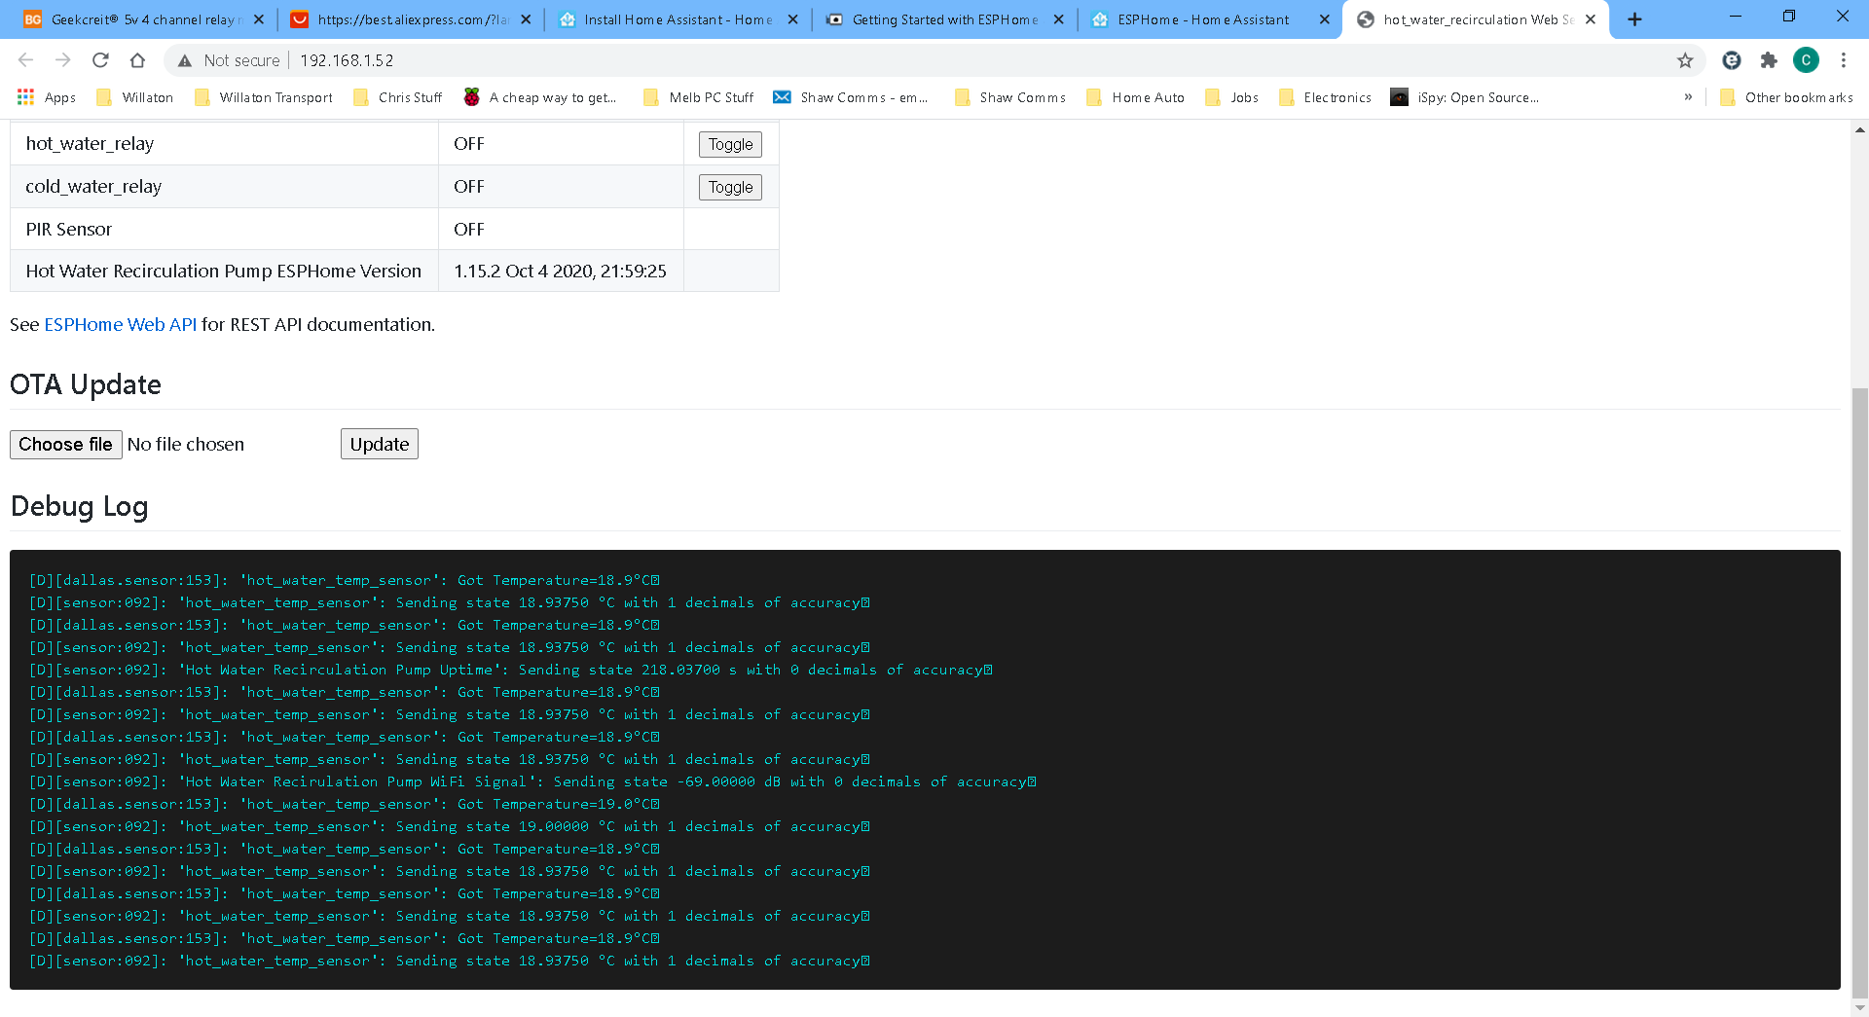

You can also click the light blue Box on the device in ESPHome to access the Web Page.
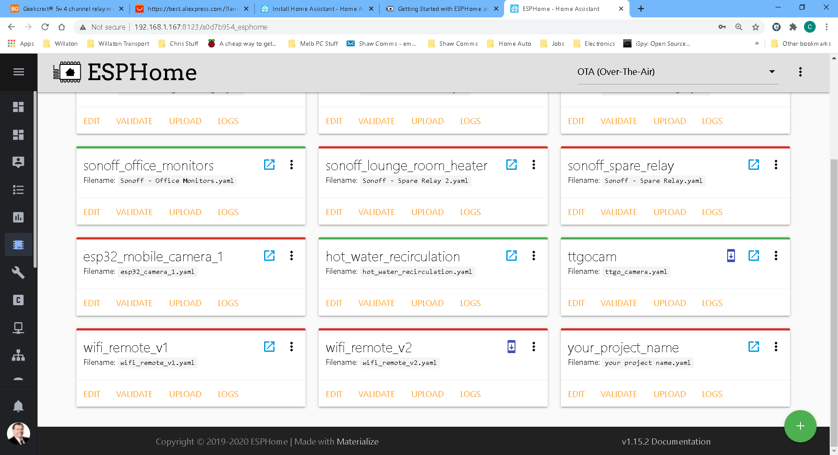

This was a great project with some re world beneifiets such as saving over 3,000 liters of water per year.

Thank you for reading.

